Created by: David Rubio G.
Blog: https://soceame.wordpress.com/
GitHub: https://github.com/DRubioG
Last modification date: 10/03/25

In this post I’m going to explain how to generate a single bitstream with the Libero bitstream and the binary generated by the SoftConsole.
This is very useful when you want to record many SoCs with the same bitstream, such as when you are manufacturing PCBs.
To do this you first need to know the basics of how Libero and SoftConsole work.
https://soceame.wordpress.com/2025/03/09/basic-project-with-libero/
https://soceame.wordpress.com/2025/03/09/how-to-create-a-project-for-a-smartfusion2-board/
And you also need to be clear about how the SoftConsole compilation profiles are configured.
https://soceame.wordpress.com/2025/03/10/how-to-compile-and-debug-in-softconsole-for-smartfusion2/

Part one
First you have to have a project developed in SoftConsole, for this you need to have created a project in Libero where you configure the MSS.
Once you have the project in SoftConsole tested, debugged and you want to unify it with the Libero bitstream we can start generating it.
The first thing to do is change the debug compilation profile to Release.
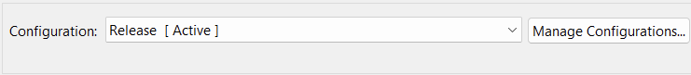
Then you have to configure the same thing that is configured for debugging except the Script files. This is done in the following way:
- set the compiler flags
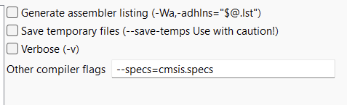
- And the –specs=nano.specs.
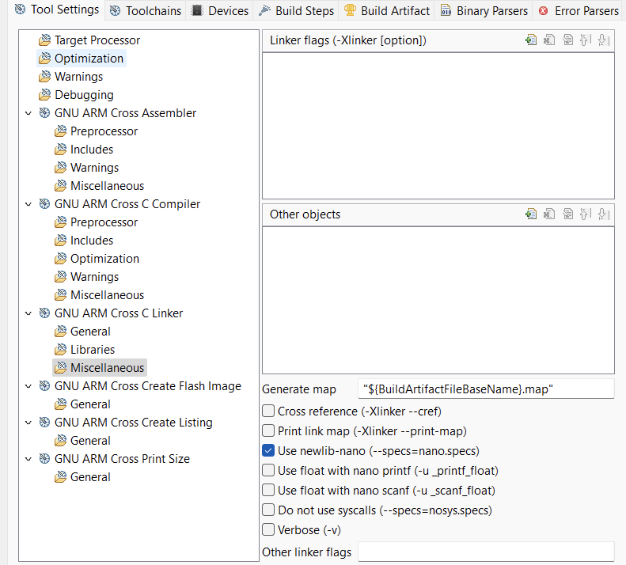
And what we have to change is the Script File in GNU ARM Cross C Linker.
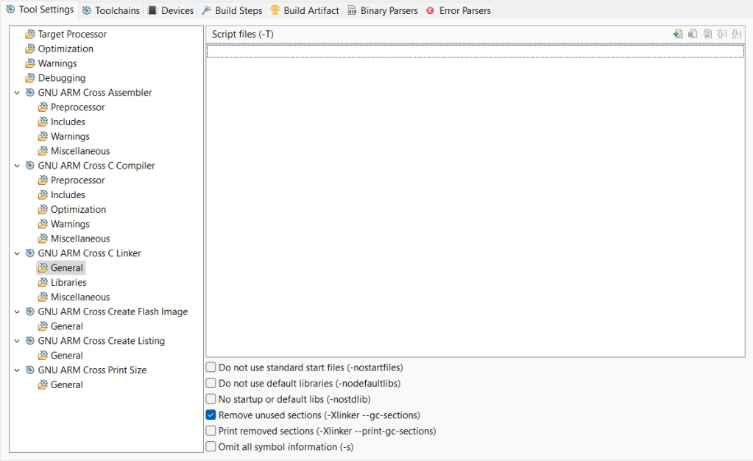
We add a new Script file from the Workspace.
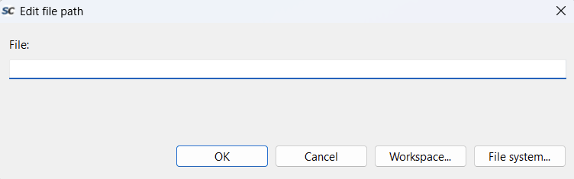
And now we change the file from a debug file to a production file. Two production options appear, to save it internally or externally. In our case we chose internally (production-smartfusion2-executable-in-place.ld).
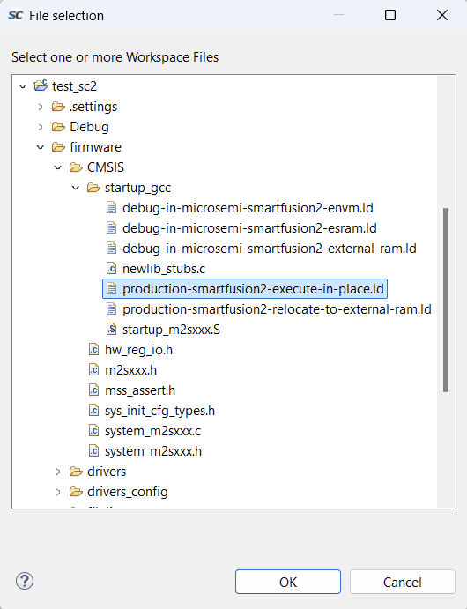
Now it appears selected.
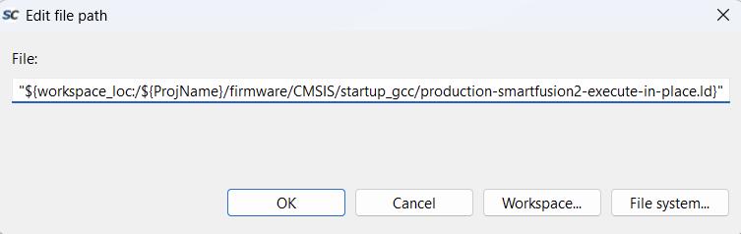
The file appears in the interface.
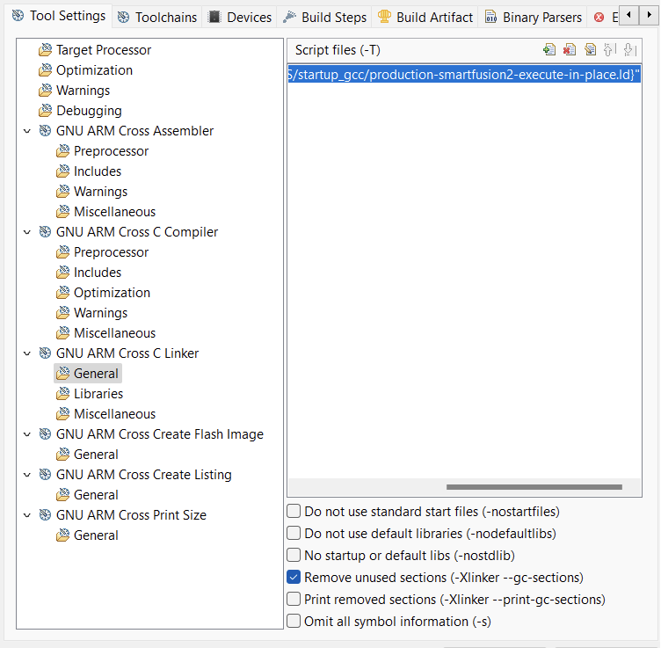
Well, once we have done all this, we can compile the project again.
When we do this, a new folder called Release appears.
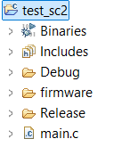
This folder contains the file we need to create the single bitstream, it is the .hex file. This file is the one we have to take to Libero.
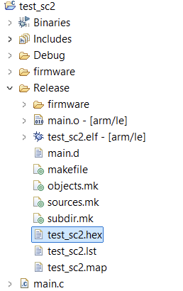

Second part
Once we have generated the .hex in Release, NOT in Debug, because in Debug Libero does not allow the use of that .hex, we return to the initial Libero project.
We return to this MSS configuration tab.
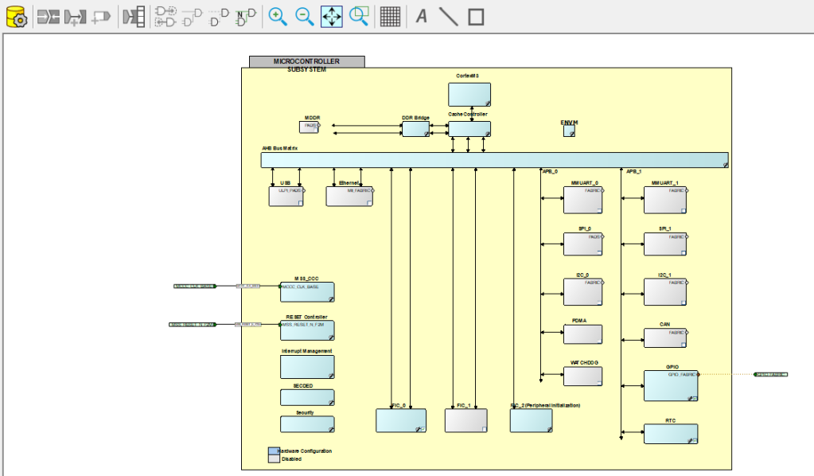
And we have to go to the ENVM option, which is the one that allows saving certain files in non-volatile memory within the MSS.
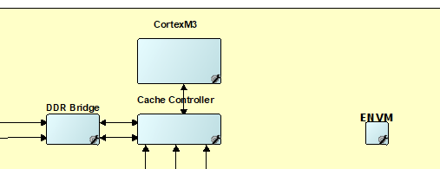
When we click on it, a tab like this one opens, empty.
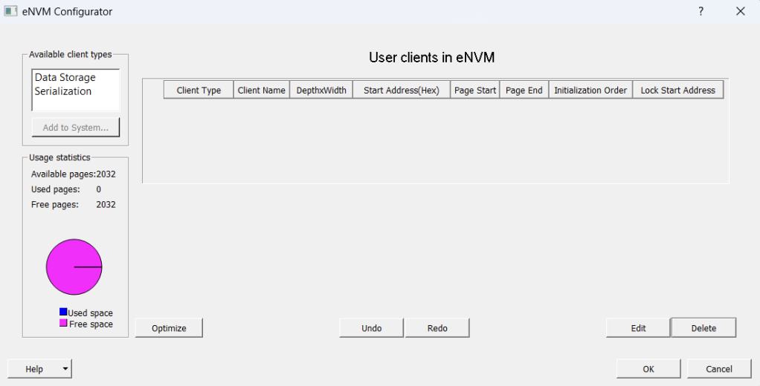
Now we click on Data Storage and Add to System.
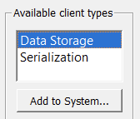
A tab like the following one opens, which asks us for two things, to give a name to the memory structure and a valid .hex file, which is the one we generated previously.
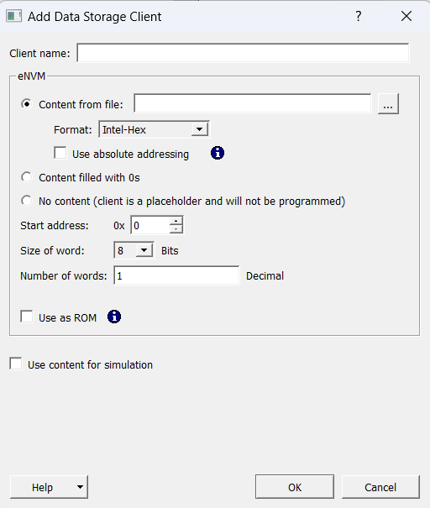
We give it a name and a valid production .hex. We also check the Use as ROM box.
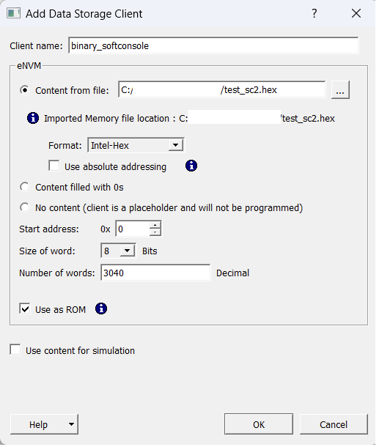
The Use as ROM is so that all the masters can read it, but not modify it.
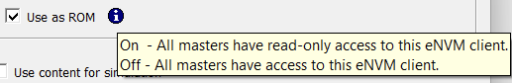
After adding the new memory layer, it appears in the tab.
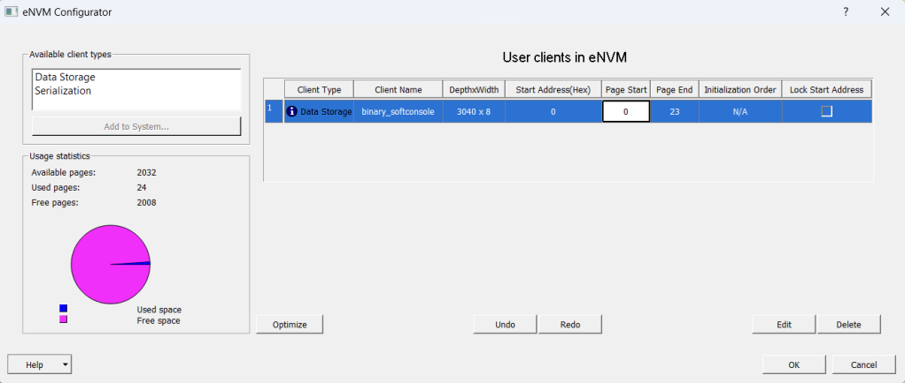
Now all we have to do is click on the yellow gear icons and the Build Hierarchy button.
Once we have the project rebuilt and ready, we synthesize it and generate the bitstream.
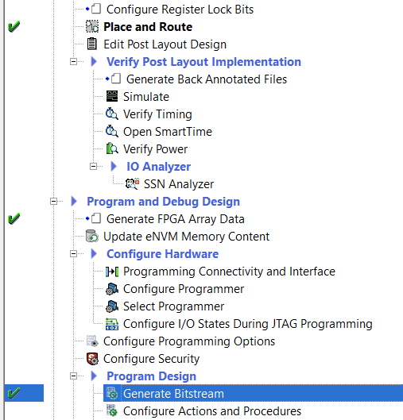
This bitstream that we have generated contains the .hex that we have created. Now we just need to export it to record it with FlashPro Express.
In this post I leave you how to install and use FlashPro Express.
https://soceame.wordpress.com/2025/03/09/flashpro-express-tutorial-installing-and-running/
NOTE: the Update eNVM Memory Content option takes us to the tab where we have entered the SoftConsole binary (.hex).
